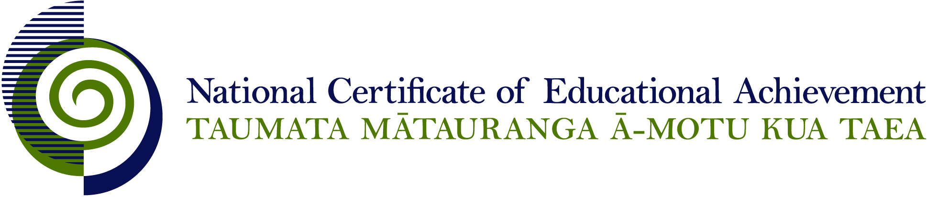

NCEA Level 2 Physical Education

Conditions of Assessment

General Information

Subject Reference | Health and Physical Education
Domain | Physical Education
Level | 2

Conditions of Assessment

These Conditions provide guidelines for assessment against internally assessed Achievement Standards. Guidance is provided on:
- specific requirements for all assessments against this Standard
- appropriate ways of, and conditions for, gathering evidence
- ensuring that evidence is authentic.

Assessors must be familiar with guidance on assessment practice in learning centres, including enforcing timeframes and deadlines. The NZQA website offers resources that would be useful to read in conjunction with these Conditions of Assessment.

The learning centre’s Assessment Policy and Conditions of Assessment must be consistent with NZQA’s Assessment Rules for Schools with Consent to Assess. This link includes guidance for managing internal moderation and the collection of evidence.

Gathering Evidence

Internal assessment provides considerable flexibility in the collection of evidence. Evidence can be collected in different ways to suit a range of teaching and learning styles, and a range of contexts of teaching and learning. Care needs to be taken to allow students opportunities to present their best evidence against the Standard(s) that are free from unnecessary constraints.

It is recommended that the design of assessment reflects and reinforces the ways students have been learning. Collection of evidence for the internally assessed Standards could include, but is not restricted to, an extended task, an investigation, digital evidence (such as recorded interviews, blogs, photographs, or film), or a portfolio of evidence.

Effective assessment should suit the nature of the learning being assessed, provide opportunities to meet the diverse needs of all students, and be valid and fair.

Where all, or a significant part, of the evidence for assessment is presented orally, this will need to be recorded (audio or video) and annotated for in-school and national moderation purposes. Note that the judgement made about the quality of the work is not made on the quality of the ‘oral performance’ but the meaning inherent in the verbal presentation (or in the written notes students will likely prepare to support the presentation).

Ensuring Authenticity of Evidence

Authenticity of student evidence needs to be assured regardless of the method of collecting evidence. This must be in line with the learning centre’s policy and NZQA’s Assessment Rules for Schools with Consent to Assess.

Ensure that the student’s evidence is individually identifiable and represents the student’s own work. The evidence must be an accurate reflection of what the student independently knows and can do, according to the Standard being assessed. This includes evidence submitted as part of a group assessment, evidence produced outside of class time or without assessor supervision, and evidence produced with any use of generative artificial intelligence tools (GenAI). GenAI use should be carefully considered in the context of the Standard being assessed and its Conditions of Assessment, discussed with students before the assessment, and its use must be acknowledged. For example, an investigation carried out over several sessions could include:
- teacher guidance on the nature and extent of acceptable GenAI use, if any
- assessor observations and conversations
- meeting with the student at set milestones or checkpoints
- the student’s record of progress, such as photographic entries or any GenAI prompts used.

Specific Information for Individual Internal Achievement Standards

Achievement Standard Number | 91327 Physical Education 2.1
Title | Examine the role and significance of physical activity in the lives of young people in New Zealand
Number of Credits | 3
Version | 2

NB: It is important to read the section “For All Standards” at the start of this document.

Achievement Standard Number | 91328 Physical Education 2.2
Title | Demonstrate understanding of how and why biophysical principles relate to the learning of physical skills
Number of Credits | 5
Version | 2

NB: It is important to read the section “For All Standards” at the start of this document.

Achievement Standard Number | 91329 Physical Education 2.3
Title | Demonstrate understanding of the application of biophysical principles to training for physical activity
Number of Credits | 4
Version | 2

NB: It is important to read the section “For All Standards” at the start of this document.

Achievement Standard Number | 91330 Physical Education 2.4
Title | Perform a physical activity in an applied setting
Number of Credits | 4
Version | 3

NB: It is important to read the section “For All Standards” at the start of this document.

Guidelines for developing assessment activities and using the rubrics for many contexts can be found at this link:
http://www.nzqa.govt.nz/assets/qualifications-and-standards/qualifications/ncea/NCEA-subject-resources/PE/Rubrics-L2.docx

This standard could be assessed through ongoing assessment opportunities.
Evidence for this assessment is collected through teacher observation.

Achievement Standard Number | 91331 Physical Education 2.5
Title | Examine the significance for self, others and society of a sporting event, a physical activity, or a festival
Number of Credits | 4
Version | 2

NB: It is important to read the section “For All Standards” at the start of this document.

Achievement Standard Number | 91332 Physical Education 2.6
Title | Evaluate leadership strategies that contribute to the effective functioning of a group
Number of Credits | 4
Version | 2

NB: It is important to read the section “For All Standards” at the start of this document.

Achievement Standard Number | 91333 Physical Education 2.7
Title | Analyse the application of risk management strategies to a challenging outdoor activity
Number of Credits | 3
Version | 2

NB: It is important to read the section “For All Standards” at the start of this document.

Achievement Standard Number | 91334 Physical Education 2.8
Title | Consistently demonstrate social responsibility through applying a social responsibility model in physical activity
Number of Credits | 3
Version | 2

NB: It is important to read the section “For All Standards” at the start of this document.

This assessment should be completed in authentic practical situations where the teacher/coach/instructor can observe the demonstration of social responsibility.

Evidence for the level of responsibility through applying a social responsible model in physical activity will be collected through teacher/self/peer observations over a period of time.

Achievement Standard Number | 91335 Physical Education 2.9
Title | Examine the implementation and outcome(s) of a physical activity event or opportunity
Number of Credits | 3
Version | 2

NB: It is important to read the section “For All Standards” at the start of this document.

Achievement Standard Number | 91336 Physical Education 2.10
Title | Analyse group processes in physical activity
Number of Credits | 3
Version | 2

NB: It is important to read the section “For All Standards” at the start of this document.

